SAMPLE

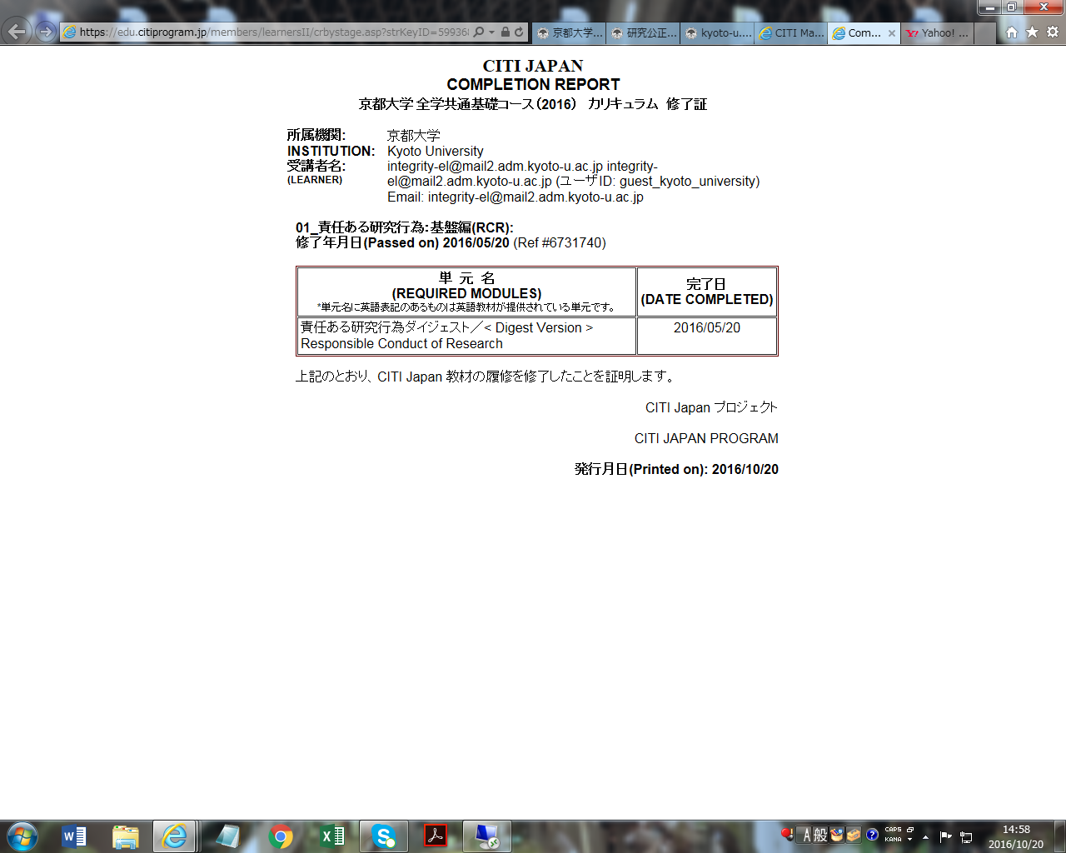

Your name and E-mail address